## TASK 1: Modelling of a Link in SimMechanics

## Block Diagram:

## 

## Deliverables:

1. Following is the image of the SimMechanics explorer window showing the developed link and all the coordinate frames.

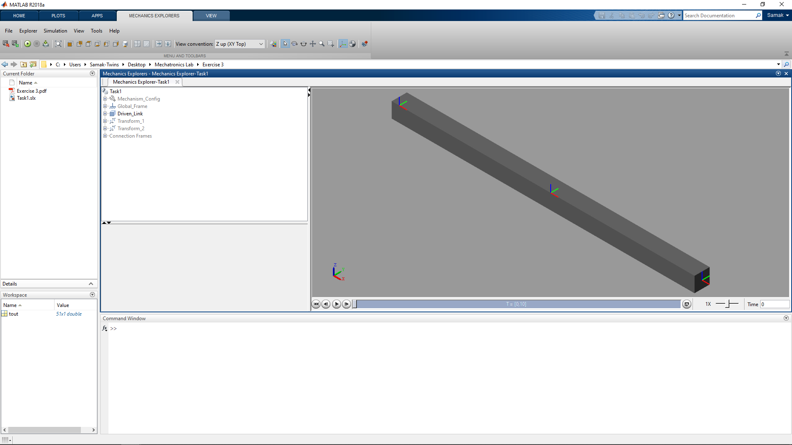

## TASK 2: Modelling of a Mechanism in SimMechanics

## Block Diagram:

## 

## Deliverables:

1. Following is the image of the SimMechanics explorer window showing the developed link with the pivot block connected with a revolute joint and all the coordinate frames.

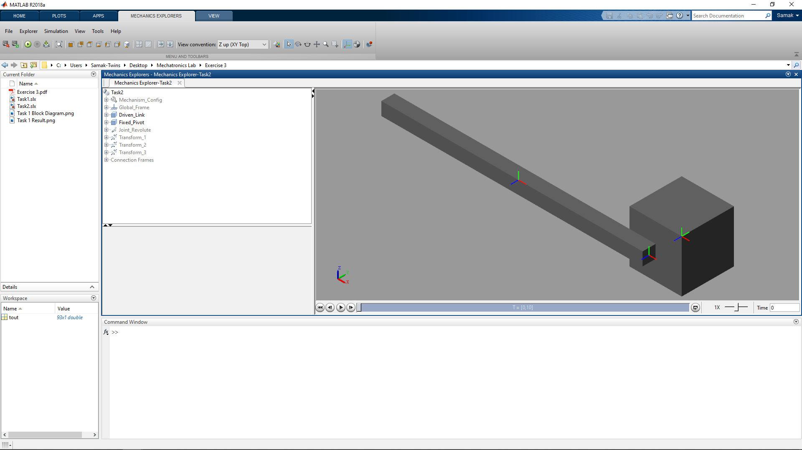

## TASK 3: Analysis of the Dynamic Response of the Model

## 3.1: Undamped Revolute Joint

## Block Diagram:

## 

## Deliverables:

1. Following is the plot of joint angle (rad) and joint velocity (rad/s) w.r.t. time (s) for undamped revolute joint

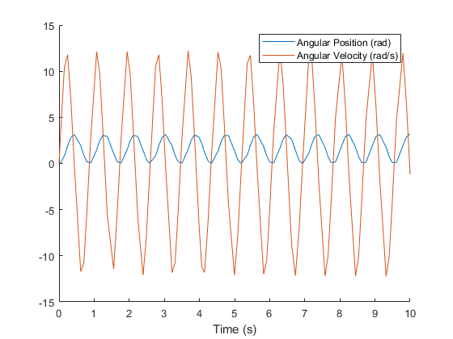

1. Following is the plot of joint angle (rad) vs. joint velocity (rad/s) for undamped revolute joint

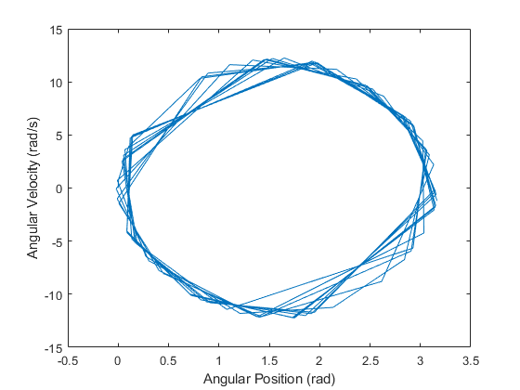

## 3.2: Damped Revolute Joint

## Block Diagram:

## 

## Deliverables:

1. Following is the plot of joint angle (rad) and joint velocity (rad/s) w.r.t. time (s) for damped revolute joint

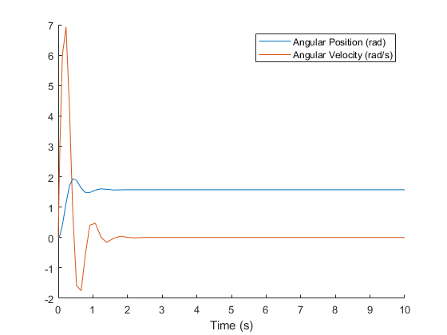

1. Following is the plot of joint angle (rad) vs. joint velocity (rad/s) for damped revolute joint

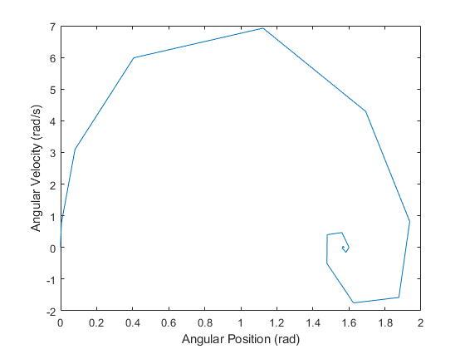

## 3.3: Driven Revolute Joint

## Block Diagram:

## 

## Deliverables:

1. Following is the plot of joint angle (rad) and joint velocity (rad/s) w.r.t. time (s) for driven revolute joint

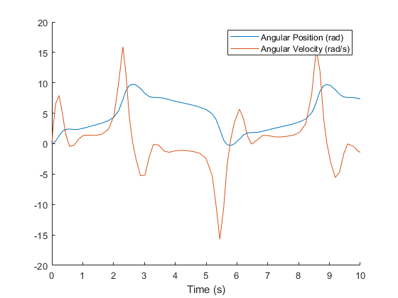

1. Following is the plot of joint angle (rad) vs. joint velocity (rad/s) for driven revolute joint

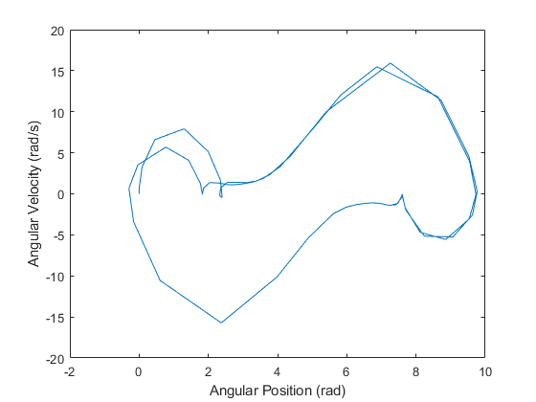

## TASK 4: Actuation to Mechanism

## Block Diagram:

## 

## PWM Specifications:

## Voltage Range: 0-5 V (0-100% Duty Cycle)

## Switching Frequency: 1000 Hz

## H-Bridge Specifications:

## Enable Threshold Voltage: 2.5 V

## PWM Signal Amplitude: 5 V

## Reverse Threshold Voltage: 2.5V

## Braking Threshold Voltage: 2.5V

## Output Voltage Amplitude: 12 V

## Total Bridge Resistance: 0.1 Ohm

## Freewheeling Diode Resistance: 0.05 Ohm

## Control Voltage Specifications:

## Speed Control Voltage: 0-5 V DC

## Direction Control Voltage: 5 V AC (0.05 Hz)

## Motor Specifications:

## Motor 1:

## Armature Resistance: 0.5 Ohm

## Armature Inductance: 0.002 H

## Torque Constant: 0.05 N*m/A

## Rotor Inertia: 9e-5 kg*m^2

## Rotor Damping: 0 N*m/(rad/s)

## Initial Rotor Speed: 0 rpm

## Motor 2:

## Armature Resistance: 0.2 Ohm

## Armature Inductance: 0.005 H

## Torque Constant: 0.1 N*m/A

## Rotor Inertia: 5e-4 kg*m^2

## Rotor Damping: 0 N*m/(rad/s)

## Initial Rotor Speed: 0 rpm

## Deliverables:

1. Following are the plots of joint velocity (rad/s) w.r.t. time (s) for 2 different motor specifications and 2 different PWM duty cycles

|  |  |
| --- | --- |
|  |  |
| Motor 1 – 50% Duty Cycle | Motor 1 – 100% Duty Cycle |
|  |  |
| Motor 2 – 50% Duty Cycle | Motor 2 – 100% Duty Cycle |

## LAB SESSION SCREENSHOT

## 

## INFERENCE

This experiment gave a deeper understanding about physical modeling using SimMechanics (a simplified yet powerful approach to dynamic system modelling) and simulation of dynamic systems using a case study of a simple 1 DOF (rotational) mechanism, which is a typical mechatronics-based design approach. Moreover, the various tasks in this exercise helped gain a step by step knowledge about physical modeling of the said mechanism starting with minimal required components (Driven Link with appropriate Coordinate Transforms w.r.t. World Frame and gravity along negative z-axis configured using Mechanism Configuration block) and then gradually adding more (Pivot, Revolute Joint, Voltage Sources, Controlled PWM Voltage, H-Bridge, DC Motor, etc.) in the subsequent tasks to get a more detailed physical model. That being said, there is still a room for adding physical aspects such as gearbox, friction, damping, drag, actuator saturation limits, etc. in order to obtain a more realistic physical model of the system.

From this experiment, it is evident that MATLAB - Simulink is a very powerful tool when it comes to modelling and simulation of dynamic systems ranging from simple 1-DOF mechanisms (as modeled and simulated in this exercise) to highly complex multi-disciplinary systems. It provides a range of built-in functions and toolboxes for rapid system analysis across multiple representation types (including Simulink as well as Physical System blocks – it is an important inference that Simulink blocks represent only numerical data whereas Physical System blocks represent a specific physical quantity along with its associated unit/dimension).